**Classroom of the Elite Season 2: Release and other Details!** 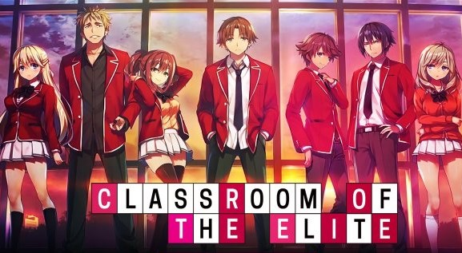

**Classroom of the Elite**, a Japanese television **series** based on the manga series written by Shogo Kinugasa and illustrated by Shunsaku Tomose. It's directed by Seiji Kishi and Hiroyuki Hashimoto. Media Factory is its publisher.

**Classroom of the Elite Season 2: Release Date**

**Classroom of the Elite Season** 1 premiered from July 12 to September 27, 2017, on ATX, Tokyo MX, and other channels. From that time onwards, its fans are waiting for **season 2**. And as of yet, there's no official news on the production of **Classroom of the Elite Season 2**. But, if we see the possibility of its **release** and production then it'll be filmed for sure because of the availability of enough content in the light novel series and even from the benefits point of view as it was able to secure at least the money spent on the production of its first season from the selling of the light novel series. So, it depends on the production team that when they plan to film and **release season 2** if they're ever going to make one.

**Classroom of the Elite Season 2: Probable Cast**

Most of the characters are likely to repeat as per the storyline in the original light novel **series**. So, let's see a few of them:

|  |  |  |
| --- | --- | --- |
| Character | Voice actor Japanese | Voice actor English |
| Kiyotaka Ayanokoji | Shoya Chiba | Justin Briner |
| Suzune Horikita | Akari Kito | Felecia Angelle |
| Kikyou Kushida | Yurika Kubo | Sarah Wiedenheft |
| Airi Sakura | M.A.O | Leah Clark |
| Kei Karuizawa | Ayana Taketatsu | Bryn Apprill |
| Yousuke Hirata | Ryota Osaka | Dallas Reid |
| Rokusuke Kouenji | Toshiki Iwasawa | Christopher Wehkamp |
| Ken Sudou | Eiji Takeuchi | Brandon Mclnnis |
| Kanji Ike | Daiki Abe | Aaron Dismuke |
| Haruki Yamauchi | Mutsuki Iwanaka | Travis Mullenix |
| Teruhiko Yukimura | Tsubasa Goda | Josh Grelle |
| Kakeru Ryuuen | Masaaki Mizunaka | Eric Vale |
| Mio Ibuki | Mikako Komatsu | Jamie Marchi |
| Honami Ichinose | Nao Toyama | Kristi Rothrock |
| Ryuuji Kanzaki | Akihisa Wakayama | Ricco Fajardo |
| Arisu Sakayanagi | Rina Hidaka | Trina Nishimura |
| Kouhei Katsuragi | Satoshi Hino | Jarrod Greene |
| Manabu Horikita | Yuichiro Umehara | David Matranga |
| Akane Tachibana | Konomi Kohara | Apphia Yu |
| Sae Chabashira | Rina Sato | Jennifer Alyx |
| Chie Hoshinomiya | Hisako Kanemoto | Sara Ragsdale |

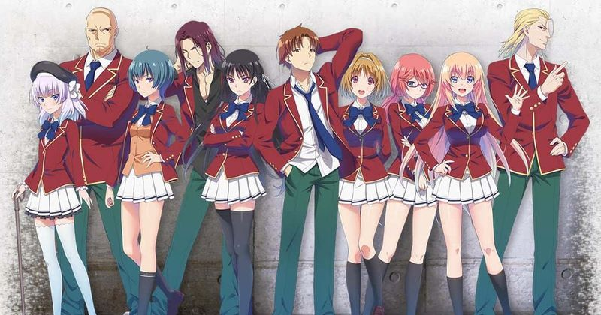**Kiyotaka Ayanokoji**- He's the lead character of the anime series. He's a D-Class student with an intentionally average grade i.e., he can get good grades and he can be in A-Class but anyhow he's willing to be in D-Class. He's very conscious of how to utilize his points. He's very skilled in martial arts but he doesn't show any interest in exhibiting his sporting capabilities. He's a person with a mysterious background who likes to get his work done by other people and staying himself in the background. He feels trouble while communicating with other people cause he's introverted kind but he thinks that friends are important.

Suzune Horikita- She's also a D-Class student who sits beside Kiyotaka and doesn't like to make friends and interact with many people because she thinks that friends are not necessary. She's also smart enough who knows how to spend her points wisely. She's the smaller sister of the school's Student Council President but he distances himself from her because of the embarrassment that she's in D-Class. She's also good at martial arts.

Kikyou Kushida- She's also a D-Class student who shows resentment towards Horikita who belongs from the same middle school as she and she knows about Kikyou's dark mysterious past. She's a friendly person but another side of her is very manipulative and violent.

Airi Sakura- She's also a D-Class student who's good at photography. She's having difficulties communicating with other people because of her nervousness and fear. She was harassed by a stalker until Kiyotaka and Hanami save her. So, she feels indebted to them and works on improving herself by idolizing Kiyotaka's ideas.

Kei Karuizawa- She's one of the top students of Class-D who lately develops a crush on Kiyotaka which was very obvious because of her jealousness towards Maya Sato, who confessed to Kiyotaka. She's very close to Kiyotaka in the anime as we can see both of them call each other by their first names and Kiyotaka also trusts her more than any other person in the anime.

**Classroom of the Elite Season 2: Expected Plot**

**Season 2** is likely to revolve around Kiyotaka's mysterious past and its revelation. It's likely to revolve around other D-Class students and will see if any student like Horikita will manage to get to Class A. The storyline is likely to be adapted from the Teen books of **Classroom of The Elite** since the first **season** used only three volumes. So, the plotline will continue from volume 4 of the light novel series.